Kinetics HW
PSI AP Chemistry Name____________________________
Reaction rates
1) A burning splint will burn more vigorously in pure oxygen than in air because
A) oxygen is a reactant in combustion and concentration of oxygen is higher in pure oxygen than it is in air.
B) oxygen is a catalyst for combustion.
C) oxygen is a product of combustion.
D) nitrogen is a product of combustion and the system reaches equilibrium at a lower temperature.
E) nitrogen is a reactant in combustion and its low concentration in pure oxygen catalyzes the combustion.

2) As the temperature of a reaction is increased, the rate of the reaction increases because the
A) reactant molecules collide less frequently
B) reactant molecules collide more frequently and with greater energy per collision
C) activation energy is lowered
D) reactant molecules collide less frequently and with greater energy per collision
E) reactant molecules collide more frequently with less energy per collision

3) Which substance in the reaction below either appears or disappears the fastest?
4NH₃ + 7O₂ 4NO₂ + 6H₂O
A) NH₃
B) O₂
C) NO₂
D) H₂O
E) The rates of appearance/disappearance are the same for all of these.

4) At elevated temperatures, dinitrogen pentoxide decomposes to nitrogen dioxide and oxygen: 2N₂O₅ (g) 4NO₂ (g) + O₂ (g). When the rate of formation of NO₂ is 5.0 x10⁻⁴M/s, the rate of decomposition of N₂O₅ is __________ M/s.
A) 2.2 x 10⁻³
B) 1.4 x 10⁻⁴
C) 1.01 x 10⁻⁴
D) 2.5 x 10⁻⁴
E) 5.5 x 10⁻⁴

5) At elevated temperatures, dinitrogen pentoxide decomposes to nitrogen dioxide and oxygen: 2N₂O₅ (g) 4NO₂ (g) + O₂ (g). When the rate of formation of oxygen is 2.2 x10⁻⁴ M/s, the rate of decomposition of N₂O₅ is __________ M/s.
A) 1.1 x 10⁻⁴
B) 2.2 x 10⁻⁴
C) 2.8 x 10⁻⁴
D) 4.4 x 10⁻⁴
E) 5.5 x 10⁻⁴

6) Which one of the following is not a valid expression for the rate of the reaction below?
4NH₃ + 7O₂ 4NO₂ + 6H₂O
A)
B)
C)
D)
E) All of the above are valid expressions of the reaction rate.

7) Changes in which of the factors affect both rate and rate constant?
I- temperature II- concentration
- I only
- II only
- Both I and II
- Neither I or II
8) which statement is true about a reactant that appears in the balanced equation for a reaction but does not appear in the rate equation?

- It is a catalyst
- It is an inhibitor
- Its concentration is too low to be important
- It takes part in the reaction after the rate determining step

9) Which change will decrease the rate of the reaction between I₂ (s) and H₂(g)?
A) increase the partial pressure of H₂ (g)
B) adding I₂ (s) as one piece rather than as several small portions
C) heating the mixture
D) adding a catalyst for the reaction
E) removing H₂(g)

Rate Laws/ Order of reactions
10) A reaction was found to be second order in carbon monoxide concentration. The rate of the reaction __________ if the [CO] is doubled, with everything else kept the same.
A) doubles
B) remains unchanged
C) triples
D) increases by a factor of 4
E) is reduced by a factor of 2

11 If the rate law for the reaction, 2A + 3B products is first order in A and second order in B, then the rate law is R =
A) k[A][B]
B) k[A]²[B]³
C) k[A][B]²
D) k[A]²[B]
E) k[A]²[B]²
12) The overall order of a reaction is 2. The units of the rate constant for the reaction are __________.
A) M/s
B) M⁻¹s⁻¹
C) 1/s
D) 1/M
E) s/M²

13) The kinetics of the reaction below were studied and it was determined that the reaction rate increased by a factor of 9 when the concentration of B was tripled. The reaction is __________ order in B. A + B → P
A) zero
B) first
C) second
D) third
E) one-half

14) The kinetics of the reaction below were studied and it was determined that the reaction rate did not change when the concentration of B was tripled. The reaction is __________ order in B. A + B → P
A) zero
B) first
C) second
D) third
E) one-half

15) A reaction was found to be third order in A. Increasing the concentration of A by a factor of 3 will cause the reaction rate to __________.
A) remain constant
B) increase by a factor of 27
C) increase by a factor of 9
D) triple
E) decrease by a factor of the cube root of 3

16) A reaction was found to be zero order in A. Increasing the concentration of A by a factor of 3 will cause the reaction rate to __________.
A) remain constant
B) increase by a factor of 27
C) increase by a factor of 9
D) triple
E) decrease by a factor of the cube root of 3

17) The rate law for a reaction is rate = k[A][B]² Which one of the following statements is false?
A) The reaction is first order in A.
B) The reaction is second order in B.
C) The reaction is second order overall.
D) k is the reaction rate constant
E) If [B] is doubled, the reaction rate will increase by a factor of 4.

Integrated Rate Laws and Half Life

18) For a first-order reaction, a plot of __________ versus __________ is linear.
A) ln [A]_{t}, 1/t
B) ln [A]_{t}, t
C) 1/[A]_{t}, t
D) [A]_{t}, t
E) t, 1/[A]_{t}

19). A reaction was observed for 20 days and the percentage of the reactant remaining after each day was observed in the table above. Which of the following best describes the order and the half life of the reaction?
Reaction order half life (days)
- 1st 3
- 1st 10
- 2nd 3
- 2nd 6
- 2nd 10

20. The specific rate constant k for radioactive element X is 0.023 min ⁻¹. What weight of X was originally present in a sample if 40. grams is left after 60. minutes?
A) 10. grams
B) 20. grams
C) 80. grams
D) 120 grams
E) 160 grams

21). Rate = k[X]
For the reaction whose rate law is given above, a plot of which of the following is a straight line?
A) [X] versus time
B) log [X] versus time
C) 1/[X] versus time
D) [X] versus 1/time
E) log [X] versus 1/time
22). Which of the following is a graph that describes the pathway of reaction that is endothermic and has high activation energy?
A 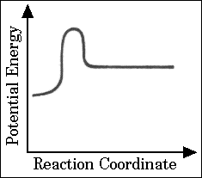 B 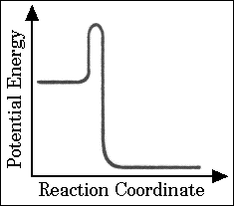 C. 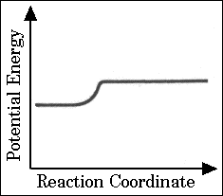 D 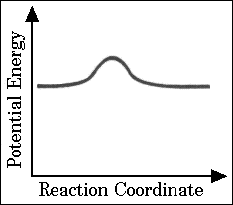

E 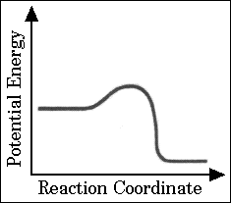

23) . If 87.5 percent of a sample of pure X decays in 24 days, what is the half-life of X?
(A) 6 days
(B) 8 days
(C) 12 days
(D) 14 days
(E) 21 days

24) The reaction 2NOBr_{(g)} → 2NO_{(g)} + Br_{2(g)}
is a second-order reaction with a rate constant of 0.50 M⁻¹s⁻¹at 11^{ᵒ}C. If the initial concentration of NOBr is 1.0 M, the concentration of NOBr after 10.0 seconds is __________.
A) 0.0500 M
B) 0.0250 M
C) 0.0312 M
D) 0.5000 M
E) 0.0625 M

25) The following reaction is second order in [A] and the rate constant is 0.039 M⁻¹s⁻¹ A → B The concentration of A was 0.30 M at 23 s. The initial concentration of A was __________ M.
(May use calculator)
A) 2.4
B) 0.27
C) 0.41
D) 3.7
E) 1.2 x 10⁻²

26) The reaction A → B is first order in [A]. Consider the following data.

Time (s) | [A] (M)
0 | 1.60
10 | 0.40
20 | 0.10
The half-life of this reaction is __________ s.
A) 0.97
B) 7.1
C) 5.0
D) 3.0
E) 0.14

27) The rate constant for this reaction is _________ s⁻¹.
A) 0.013
B) 0.030
C) 0.14
D) 3.0
E) 3.1 x 10⁻³

28) The graph shown below depicts the relationship between concentration and time for the following chemical reaction.
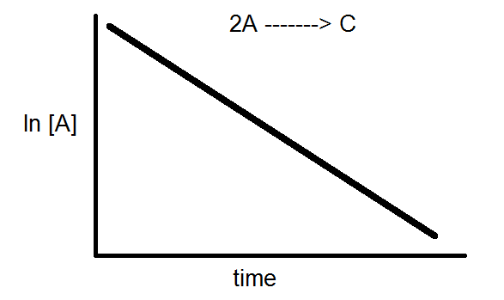
The slope of this line is equal to __________.
A) k
B) -1/k
C) ln [A]₀
D) -k
E) 1/k

29) what quantity is represented by the slope of the dashed line in the diagram below?

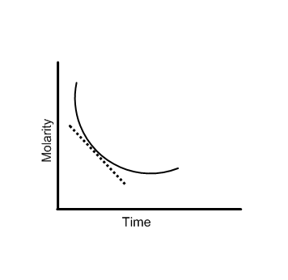
- Rate constant
- instantaneous velocity
- reaction order for that reactant
- activation energy
- Slope K

Rate mechanisms

30) Which energy difference in the energy profile below corresponds to the activation energy for the forward reaction?
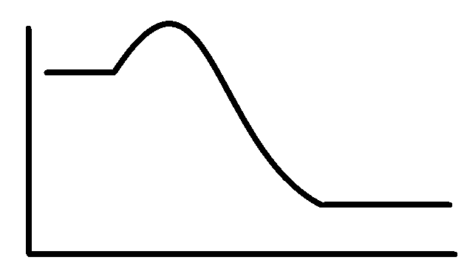
x
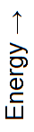

yy

Reaction Pathway
A) x
B) y
C) x + y
D) x -y
E) y- x

31) In the energy profile of a reaction, the species that exists at the maximum on the curve is called the __________.
A) product
B) activated complex
C) activation energy
D) enthalpy of reaction
E) atomic state

32) The mechanism for formation of the product X is:
A + B → C + D (slow)
B + D → X (fast)
The intermediate reactant in the reaction is __________.
A) A
B) B
C) C
D) D
E) X

33) For the elementary reaction NO₃ + CO → NO₂ + CO₂
the molecularity of the reaction is __________, and the rate law is rate = _________.

A) 2, k[NO₃][CO]
B) 4, k[NO₃][CO][NO₂][CO₂]
C) 2, k[NO₂][CO₂]
D) 2, k[NO₃][CO]/[NO₂][CO₂]
E) 4, k[NO₂][CO₂]/[NO₃][CO]

34) Which of the following is true?
A) If we know that a reaction is an elementary reaction, then we know its rate law.
B) The rate-determining step of a reaction is the rate of the fastest elementary step of its mechanism.
C) Since intermediate compounds can be formed, the chemical equations for the elementary reactions in a multistep mechanism do not always have to add to give the chemical equation of the overall process.
D) In a reaction mechanism, an intermediate is identical to an activated complex.
E) All of the above statements are true.

35) The rate law of the overall reaction A + B → C is rate = k[A]². Which of the following will not increase the rate of the reaction?
A) increasing the concentration of reactant A
B) increasing the concentration of reactant B
C) increasing the temperature of the reaction
D) adding a catalyst for the reaction
E) All of these will increase the rate.

36) A catalyst can increase the rate of a reaction __________.
A) By changing the value of the frequency factor (A)
B) By increasing the overall activation energy (E_{a}) of the reaction
C) By lowering the activation energy of the reverse reaction
D) By providing an alternative pathway with a lower activation energy
E) All of these are ways that a catalyst might act to increase the rate of reaction.
Answers:
General/ Reaction rates
- A
- B
- B
- D
- D
- E
- A
- D
- B

Rate Laws/ Order of reactions
- D
- C
- B
- C
- A
- B
- A
- C

Integrated Rate Laws

- B
- B
- B
- A
- B
- A
- C
- C
- C
- C
- D
- B

Rate mechanisms
- A
- B
- D
- A
- A
- B
- D

Conceptual questions: All sections - No calculators
37) Which of the following does NOT influence the speed of a chemical reaction?
A) Concentration of reactants
B) Nature of reactants
C) Temperature
D) Presence of a catalyst
E) None of these

38) What would cause the change in the kinetic energy diagrams as shown?
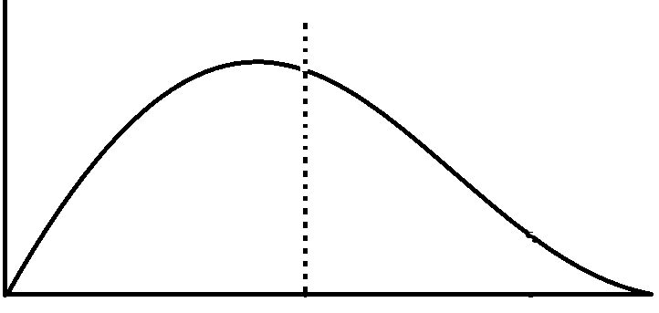
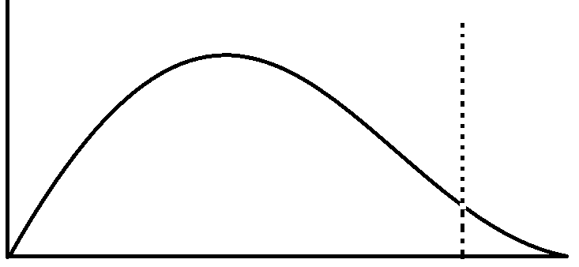

A)Decreasing the ΔH
B) Decreasing the temperature
C) Increasing the surface area
D) Addition of a catalyst
E) Increasing reactant concentration

39) A time vs. concentration graph is presented below for the reaction A → B. What is the rate of appearance of ‘B’ 15 seconds after the start of the reaction?
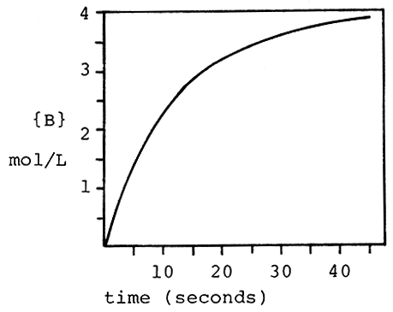
A) 0.080 mol/L⋅s
B) 1.2 mol/L⋅s
C) 2.2 mol/L⋅s
D) 0.010 mol/L⋅s
E) 9.8 mol/L⋅s

40. The reaction 3O₂ → 2O₃ is proceeding with a rate of disappearance of O₂ equal to 0.60 mol/L⋅s. What is the rate of appearance of O₃, in mol/L⋅s?
A) 0.60
B) 0.40
C) 0.10
D) 0.90
E) 1.20

41. A reaction has the rate law Rate = k [A][B].² What is the overall order of the reaction?
A) 0
B) 2
C) 1
D) 4
E) 3

42 What are the correct units for a second order rate constant?
A) mol/L⋅s
B) 1/s
C) L mol⁻¹s⁻¹
D) L²/mol²⋅s
E) mol²/L²⋅s

43. The reaction I- + OCl- → IO- + Cl- is first order with respect to I- and first order with respect to OCl-. The rate constant is 8.0 x 10⁻² L/mol⋅s. What is the rate of reaction when [I-] = 0.10 M and [OCl-] = 0.20 M?
A) 4.4 x 10⁻⁴ M/s
B) 1.60 x 10⁻³ M/s
C)4.9 x 10⁻² M/s
D) 2.2 x 10⁻⁴ M/s
E) 2.4 x 10⁻⁵ M/s

44. A reaction and its rate law are given below. When [C4H6] = 2.0 M, the rate is 0.2 M/s.
What is the rate when [C4H6] = 4.0 M?
2 C₄H₆ → C₈H₁₂ Rate = k[C4H6]²
A)0.050 M/s
B) 0.212 M/s
C)0.106 M/s
D) 0.800 M/s
E) 0.022 M/s

45. The rate law for the reaction:
2NO(g) + O₂(g) → 2NO₂(g)
is Rate = k[NO]²[O₂]. What happens to the rate when the concentration of NO is doubled?
A) the rate doubles
B) the rate triples
C) the rate quadruples
D) the rate is halved
E) none of these

46. Below is some rate data for the hypothetical reaction, 2A + B → C. What is the rate law for this reaction?
Experiment | [A]_{o} | [B]_{o} | Rate (M/s)
1 | 3.0 M | 1.0 M | 0.100
2 | 3.0 M | 2.0 M | 0.400
3 | 6.0 M | 1.0 M | 0.100
A) Rate = k[A][B]
B) Rate = k[A]²[B]
C) Rate = k[A][B]²
D) Rate = k[A]²[B]²
E) Rate = k[B]²

47. The acid catalyzed decomposition of hydrogen peroxide is a first order reaction with the rate constant given below. For an experiment in which the starting concentration of hydrogen peroxide is 0.20 M, what is the concentration of H₂O₂, 50 minutes after the reaction begins?
2H₂O₂ → 2H₂O + O₂ k=6.93 x 10⁻² min⁻¹
A) 0.061 M
B) 0.00625 M
C) 0.0010 M
D) 0.000658 M
E) 0.0125 M

48. What is the rate constant for a first order reaction for which the half-life is 69.0 sec?
A) 0.010 sec⁻¹
B) 3.45 sec⁻¹
C) 0.170 sec⁻¹
D) 0.0618 sec⁻¹
E) 69.0 sec⁻¹

49. What fraction of a reactant remains after 3 half-lives of a first order reaction?
A)1/2
B)1/16
C)1/6
D) 1/8
E) 1/12
50. Assume a reaction occurs by the mechanism given below. What is the rate law for the reaction? A + B ↔ C fast
C → D slow
A) Rate = k[A][B][C]
B) Rate = k[A]²
C) Rate = k[A][B]
D) Rate = k[A][B]/[D]
E) Rate = k[A]

51. According to collision theory, which of the following factors does NOT influence the rate of reaction?
A) collision frequency
B) collision energy
C) collision orientation
D) collision rebound direction
E) none of these
52. What distance corresponds to the activation energy for the reaction?
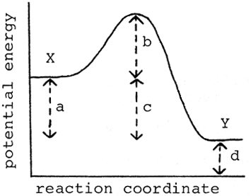
A) a
B) b
C) c
D) d
E) e

53. At what point on the potential energy diagram given below does the transition state (activated complex) occur?
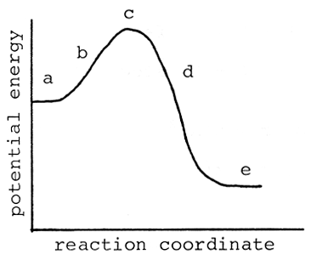
A) a
B) b
C) c
D) d
E) e

54. Which of the following is NOT true about a catalyst?
A) it speeds up the forward reaction
B) is acts as an inhibitor
C) it speeds up the reverse reaction
D) it may be homogeneous
E) it may be heterogeneous

Answers:
37) E 42) C 47) B 52) B

38) D 43) B 48) A 53) C
39) A 44) D 49) D 54) B
40) B 45) C 50) C
41) E 46) E 51) D
Free response :
- The reaction of ^{t}butyl-bromide (CH₃)₃CBr with water is represented by the equation:
(CH₃)₃CBr + H₂O → (CH₃)₃COH + HBr
The following data were obtained from three experiments using the method of initial rates:
Expt | Initial [(CH₃)₃CBr]  mol L⁻¹ | Initial [H₂O]  mol L⁻¹ | Initial rate  mol L⁻¹min⁻¹
1 | 5.0 x 10⁻² | 2.0 x 10⁻² | 2.0 x 10⁻⁶
2 | 5.0 x 10⁻² | 4.0 x 10⁻² | 2.0 x 10⁻⁶
3 | 1.0 x 10⁻¹ | 4.0 x 10⁻² | 4.0 x 10⁻⁶

a. What is the order with respect to (CH₃)₃CBr?
b. What is the order with respect to H₂O?
c. What is the overall order of the reaction?
d. Write the rate equation.
e. Calculate the rate constant k for the reaction.
2) The rate equation for the reaction of nitrogen dioxide and carbon monoxide in the gas state to form carbon dioxide and nitric oxide is represented by the equation:
NO₂(g) + CO(g) → NO(g) + CO₂(g)
The following data were collected at 125°C:
Expt | Initial [NO₂]  mol L⁻¹ | Initial [CO]  mol L⁻¹ | Initial rate  mol L⁻¹min⁻¹
1 | 5.0 x 10⁻⁴ | 1.6 x 10⁻² | 1.7 x 10⁻⁷
2 | 5.0 x 10⁻⁴ | 3.2 x 10⁻² | 1.7 x 10⁻⁷
3 | 1.5 x 10⁻³ | 3.2 x 10⁻² | 1.5 x 10⁻⁶

a. What is the order with respect to NO₂?
b. What is the order with respect to CO?
c. What is the overall order of the reaction?
d. Write the rate equation.
e. How do you know this is not a single step reaction?
f. Suggest a mechanism for the reaction.
3) Consider the reaction: 2 NO(g) + O₂(g) → 2 NO₂(g)
The following data were obtained from three experiments using the method of initial rates:
Expt | Initial [NO]  mol L⁻¹ | Initial [O₂]  mol L⁻¹ | Initial rate NO  mol L⁻¹s⁻¹
1 | 0.010 | 0.010 | 2.5 x 10⁻⁵
2 | 0.020 | 0.010 | 1.0 x 10⁻⁴
3 | 0.010 | 0.020 | 5.0 x 10⁻⁵
4

a. Determine the order of the reaction for each reactant.
b. Write the rate equation for the reaction.
c. Calculate the rate constant.
d. Calculate the rate (in mol L⁻¹s⁻¹) at the instant when [NO] = 0.015 mol L⁻¹ and [O₂] = 0.0050 mol L⁻¹
e. At the instant when NO is reacting at the rate 1.0 x 10⁻⁴ mol L⁻¹s⁻¹, what is the rate at which O₂ is reacting and NO₂ is forming?
4). The reaction 2 NO(g) + 2 H₂(g) → N₂(g) + 2 H₂O(g) was studied at 904 °C, and the data in the table were collected.
Expt | Initial [NO]  mol L⁻¹ | Initial [H₂]  mol L⁻¹ | Initial rate N₂  mol L⁻¹s⁻¹
1 | 0.420 | 0.122 | 0.136
2 | 0.210 | 0.122 | 0.0339
3 | 0.210 | 0.244 | 0.0678
4 | 0.105 | 0.488 | 0.0339

a. Determine the order of the reaction for each reactant.
b. Write the rate equation for the reaction.
c. Calculate the rate constant at 904 °C.
d. Find the rate of appearance of N₂ at the instant when [NO] = 0.350 M and [H₂] = 0.205 M.
5). 2A + 2B C + D
The following data about the reaction above were obtained from three experiments:
Expt | [A] | [B] | Initial rate of formation Of C  Mole/L⁻¹/min⁻¹
1 | 0.60 | 0.15 | 6.3 x 10⁻³
2 | 0.20 | 0.60 | 2.8 x10⁻³
3 | 0.20 | 0.15 | 7.0 x10⁻⁴

- What is the rate law for this reaction?
- What is the numerical value of the rate constant k? What are its units?

