AP Chemistry
Acid-Base Equilibria
Buffers

The Maintenance of Blood pH

Two of the most important functions of your blood are to transport oxygen and nutrients to all of the cells in your body and also to remove carbon diocese and other waste materials from them. This essential complex could not operate without several buffer systems.

The two main components of blood are blood plasma, the straw-colored liquid component of blood, and red blood cells, or erythrocytes. Erythrocytes contain a complex protein molecule called hemoglobin, which is the molecule that transports oxygen in your blood. Hemoglobin (which is represented as HHb) functions effectively as a weak monoprotic acid according to the following equilibrium:

HHb (aq) + O₂ (aq) + H₂O (l) $⇌$ HbO₂⁻ (aq) + H₃O⁺ (aq)
hemoglobin oxyhemoglobin

The system functions properly when oxygen binds to hemoglobin producing oxyhemoglobin. That oxygen is eventually released to diffuse out of the red blood cells to be absorbed by other cells to carry out metabolism. For this to occur properly, several buffer systems maintain the pH of the blood at about 7.35.

If the [H₃O⁺] is too low (pH greater than about 7.50), then equilibrium shown above shifts so far to the right that the [HbO₂⁻] is too high to allow for adequate release O₂. This is called alkalosis.

If the [H₃O⁺] is too high (pH greater than about 7.20), then equilibrium shown above shifts far enough to the right that the [HbO₂⁻] is too low. The result is that the hemoglobin’s affinity for oxygen is so reduced that the molecules won’t bind together. This is called acidosis.

The most important buffer system managing the blood pH involves H₂CO₃ and HCO₃⁻. Aqueous CO₂ produced during metabolic processes such as respiration is converted in the blood to H₂CO₃ by an enzyme called carbonic anhydrase. The carbonic acid then rapidly decomposes to bicarbonate and hydrogen ions. This is represented as:

CO₂ (aq) + H₂O (l) $⇌$ H₂CO₃ (aq) $⇌$ HCO₃⁻ (aq) + H⁺ (aq)

The buffer components are clearly recognized. For example, an addition of hydrogen ions will reduce the [HCO₃⁻ ] / [H₂CO₃] ratio and lower the pH only slightly. Coupled with the above system is the body’s remarkable ability to alter its breathing to modify the concentration of dissolved carbon dioxide. In the above example, rapid breathing would increase the loss of CO₂ to the atmosphere in the form of gaseous CO₂. This would then lower the concentration of CO₂ (aq) and further help remove any added H⁺ by driving the above reaction to the left.

Quick Check

1. Another buffer system present in blood and in other cells is the H₂PO₄-/HPO₄²⁻ buffer system.
(a) Write the net ionic equation representing the result of adding hydronium ions to a solution
containing this buffer system.

(b) Write the net ionic equation representing the result of adding hydroxide ions to a solution
containing this buffer system.

2. People under severe stress will sometimes hyperventilate, which involves rapid inhaling and
exhaling. This can lower the [CO₂] in the blood so much that a person might lose consciousness.

(a) Consider the above equilibrium and suggest the effect of hyperventilating on blood pH if the
concentration of carbon dioxide is too low.

(b) Why might breathing into a paper bag reduce the effects of hyperventilation?

Activity: Over-The-Counter Buffer Chemistry

Question:
What kinds of buffers are used in over-the-counter medicines?

Background:
Many common over-the-counter medicines employ chemical principles that you are learning about. One of the most common and effective pain relievers, or “analgesics”, is the weak acid acetylsalicylic acid (ASA), C₈H₇O₂COOH. This product is marketed under various brands, but the best-known one is Aspirin by the Bayer Corporation. (Note that anyone under the age of 18 should not use ASA as children may develop Reye’s syndrome, a potentially fatal disease that may occur with ASA use in treating flu or chickenpox.)

One form of the product contains a “buffering agent” because some people are sensitive to the acidity level of this medication. That same “buffering agent” is used in several antacid remedies to neutralize excess stomach acid (HCl).

Questions:

1. Consider the advertisement shown here and answer the questions below.
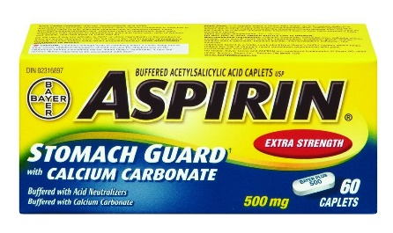
(a) Identify the ion in the compound listed on the box that acts as the
“acid neutralizer” and buffers the ASA.

(b) Write the net ionic equation corresponding to the reaction involving the “acid neutralizer” reacting
with a small amount of strong acid.

(c) Write the net ionic equation corresponding to the reaction occurring when a small amount of strong
base is added to a relatively concentrated solution of ASA.

(d) Consider the above net ionic equations and decide if a solution containing significant quantities of
ASA and the ion identified as the acid neutralizer in question 1 would function well as a buffer
solution? Why or why not?

2. Consider the antacid label shown here and note that the active ingredient is the same compound used to
buffer the ASA above.

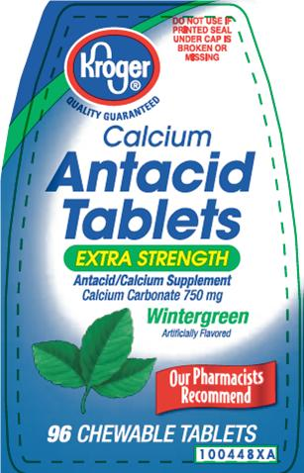

(a) Determine the pH of a buffer solution containing a 0.10 M solution of both the anion in the
compound listed and its conjugate acid.

(b) Would this solution be considered acidic or basic?

3. How would the above work with milk of magnesia, whose active ingredient is magnesium hydroxide?

