 |  | Human Hair | Pets Under microscope | Fibers found on Person
Abigail |  | 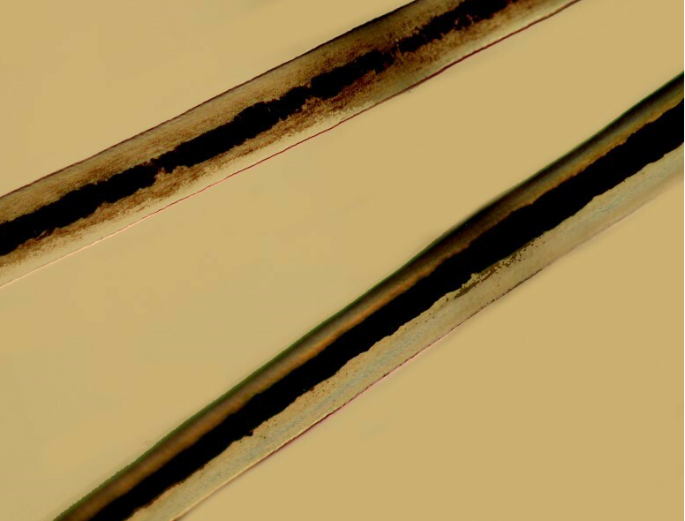 | There is a slide to look at. (Yorkie) | There is a slide to look at. (8A)
#1-George |  |  | There is a slide to look at. (#1Cat) | There is a slide to look at. (1A)
#2 Patricia |  |  | There is a slide to look at. (Bat) | N/A
#3  Helmut |  | 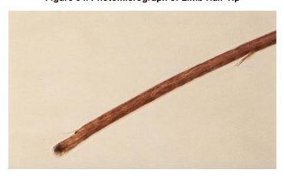 | N/A | N/A
#4  William |  |  | 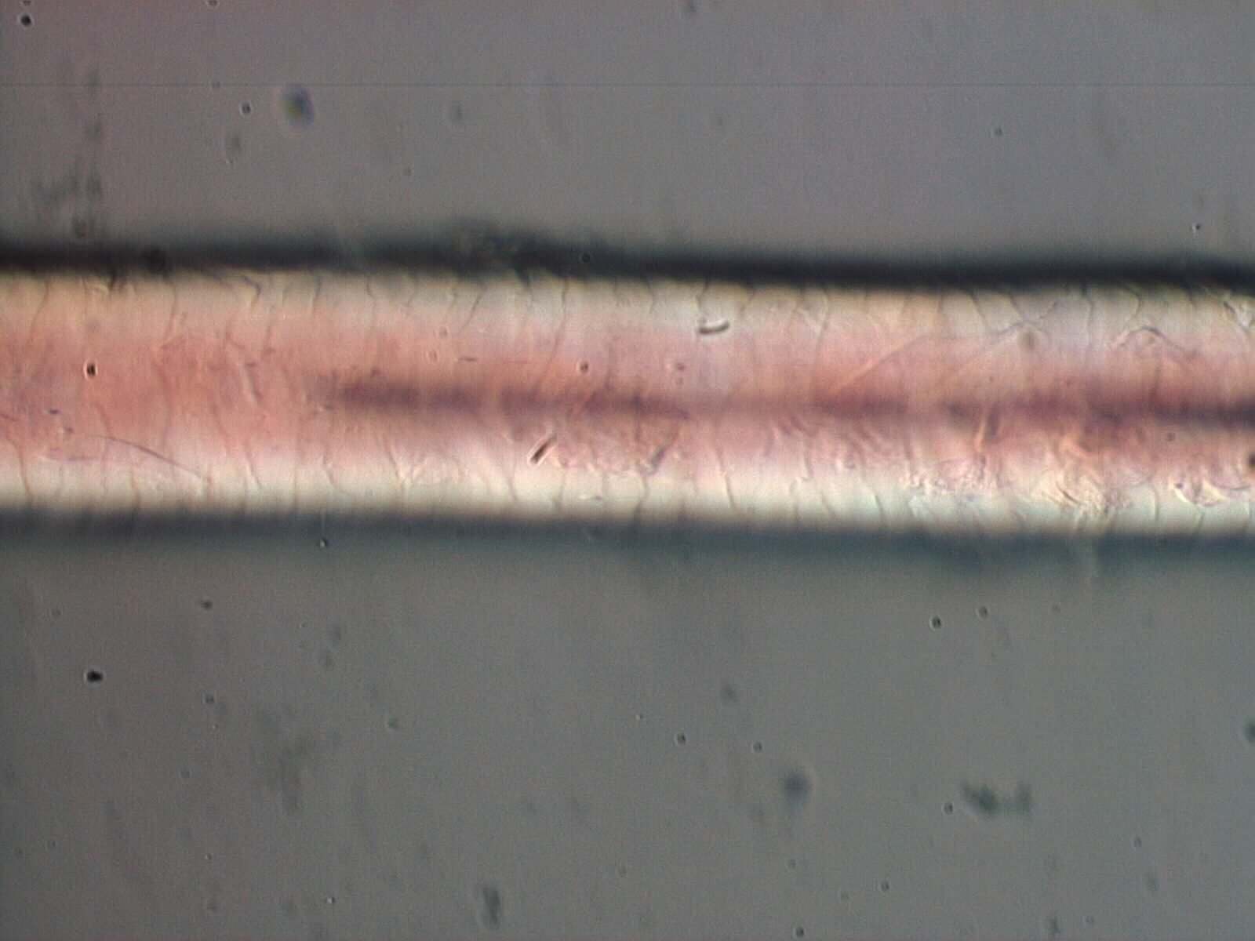 | N/A
#5  Akita |  | 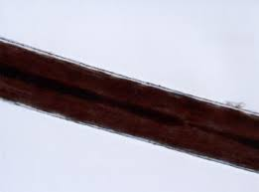 | 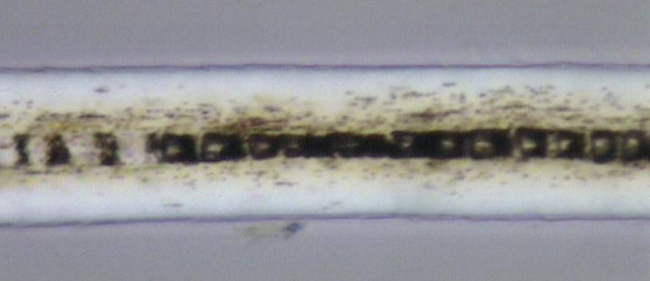 | N/A
 |  | Human Hair | Pets Under microscope
#6  Fred |  |  | There is a slide to look at (Poodle) | There is a slide to look at (6A)
#7  Maurice |  | N/A | 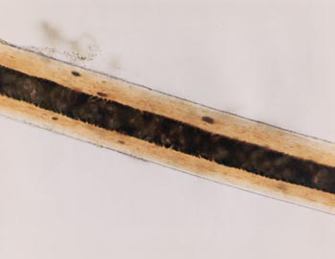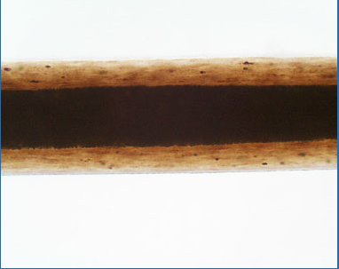

Evidence on Blanket:
-Blanket Fibers (blanket)
-Hair Sample (B)

