**Explanations of the Rates of Confusions:**

**Initial Rate🡪**

-This is the rate at the beginning (you could call this the “instantaneous” rate at the start of the rxn)

-pick a value that is very close to the start of the reaction and solve

-The example below is solving for the slope at t=0s and t=5s

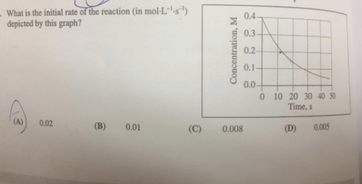

**Average Rate🡪**

-you are given a time frame and this is the average for that time

-the generic expression would be:

average rate= Δ[reactant] = Δ[reactantt2- reactantt1]

Δ[t] Δ[t2 – t1]

**Instantaneous Rate🡪**

-the rate @ a specific time

-either this can be given or you would have to draw a tangent line @ the specific time and find the slope of the line

**Rate of Rxn🡪**

-this is an expression that for the WHOLE rxn

-this can be average (“d” becomes a Δ) , initial, or instantaneous

(depends on the information you were given at the start but the expression is the same)

example: aA + bB 🡪 cC + dD

-1 d[A] = -1 d[B] = 1 [C] = 1 [D]

a d[t] b d[t] c d[t] d d[t]

**Integrated Rate Law:**

-Expresses the concentration of a reactant as a function of time

-Used to determine the concentration at any given time

-Great thing is that they are plotted in y = mx +b format to give a linear plot

-Can determine the order by finding the graph that gives a straight line (graphical analysis)

|  |  |  |  |  |
| --- | --- | --- | --- | --- |
| **Order in [A]** | **Rate**  **Law** | **Integrated Form,**  ***y* = m*x* + b** | **Straight**  **Line Plot** | **Half-Life**  **t1/2** |
| zeroth  order  (n = 0) | *rate = k [A]*o*= k* | [A]t = - *k t* +[A]o | [A]t vs. *t*  (slope = - *k*) |  |
| first  order  (n = 1) | *rate = k [A]*1 | ln[A]t = - *k t* + ln[A]o | ln[A]t vs. *t*  (slope = - *k*) |  |
| second  order  (n = 2) | *rate = k [A]*2 |  | vs. *t*  (slope = *k*) |  |