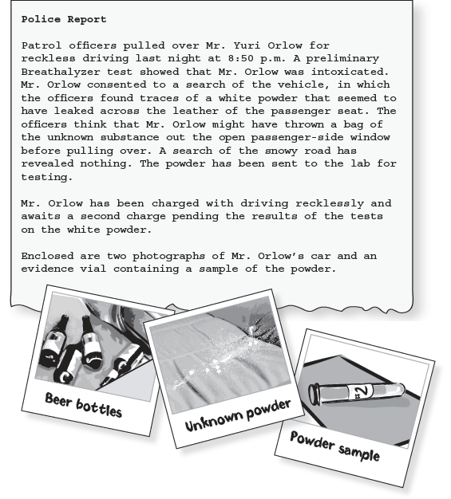

The collection of evidence at a crime scene is very important to any criminal investigation. Once this evidence has been collected and packaged properly, it is transported to the crime lab.

Crime labs frequently receive unknown substances taken from a crime scene. Experts in the crime lab have the task of determining the physical and chemical identity of these substances. Some times these mysterious substances are illegal drugs. The findings of the crime lab are important in determining the guilt or innocence of a suspect.

When trying to determine the identity of an unknown substance, crime lab experts must use testing procedure that give characteristic, distinguishable results. These test and their results must be established prior to the examination of the unknown substance. For example, if you want to determine if an unknown white powder is cocaine, you must have a previously established, positive test for cocaine. Then you can conduct this established test on an unknown white powder.

It is also important to preform more than one positive test on an unknown. Proper identification requires that you use enough different test to rule out the possibility that the unknown may be any other substance.

The forensic scientist in the crime lab must carefully perform each test on the unknown so that the identification is correct beyond a reasonable doubt.

Four standard drug samples have been provided. You will run tests on each four of the known powders and record your results. Later you will compare results with those from test of unknown powders collected at the crime scene. Your findings will determine the charges (if any) brought against Mr. Orlow.

Safety Precautions
Goggles must be worn at all times in the laboratory.
Do not ingest any of the drug samples during this laboratory. The samples are for laboratory use only, have been stored with other non-food-grade laboratory chemicals, and are not meant for human consumption. Universal indicator solution is a flammable, alcohol-based solution. Keep it away from flames.

Materials Needed
- solutions:
Marquis reagent (simulated)
Scott reagent (simulated)
Dilli-Koppanyi (simulated)
universal indicator
- flat toothpicks
- well-plate
- hand lens
- black paper
- simulated drugs and white powders: “cocaine”, “methamphetamine”, “heroin”, “amobarbital”, and “unknown”

Procedure
Part 1: Developing a positive test for the six unknown powder
Create your own procedure.

Part 2: Identification of an unknown substance
Use the results from part one to determine the identity of the substance that was recovered from Mr. Orlow’s car. Remember to write down the # of your unknown and compare your results to your data table from part 1. Be careful; your results will determine whether or not charges should be pressed against Mr. Orlow.
- Write down the letter of your unknown
- Perform all the tests from part 1 on your unknown. Record you observations/data table below.
- Compare the results to determine the identity.

Post lab Q’s:
- What unknown did you have and what was the identity of your unknown?

- Explain what data supports your conclusion for your unknown.

- Why must forensic scientists be very accurate when examining substances in the laboratory? Explain.

- Explain why Part 1 was a vital part of this experiment

Find another group and share your results with them. They will share theirs with you. After presenting to each other, answer the following questions

- What would you change if you had the opportunity to do this lab again?

- Did the group you shared with convince you of the chemical composition of their unknown? Why or why not?

- What advice would you give to them to improve their procedure to solve their problem in the future?

